**Theory Assignment 2**

|  |  |  |
| --- | --- | --- |
| Name | ID | Group |
| Amr Mohammed | 20206049 | S1 |
| Mariam AbdelAzaim | 20206150 | S1 |
| Maaryam Khamis | 20206160 | S1 |

**Problem1:**

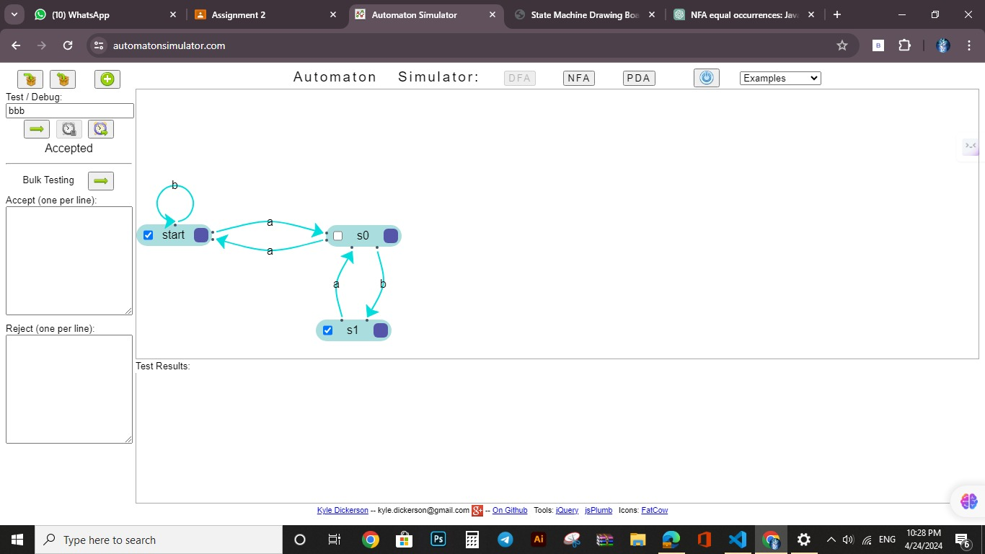

**Problem2:**

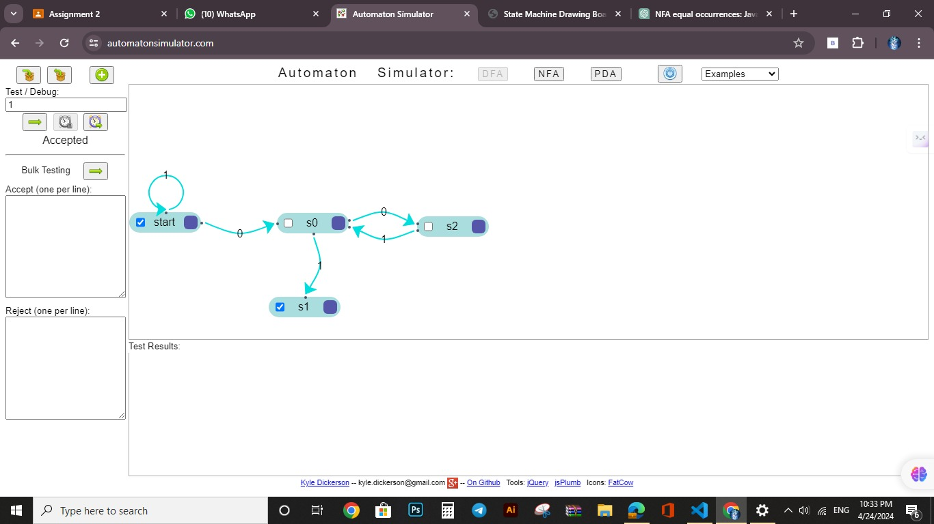

**Problem3:**

**Problem 4:**

**Problem 5:**

**Problem 6:**

**Problem 7:**

**Problem 8:**

**Problem 9:**

**Problem 10:**

